**LAB MANUAL**

**Virtual System and Services**

**CS-655**



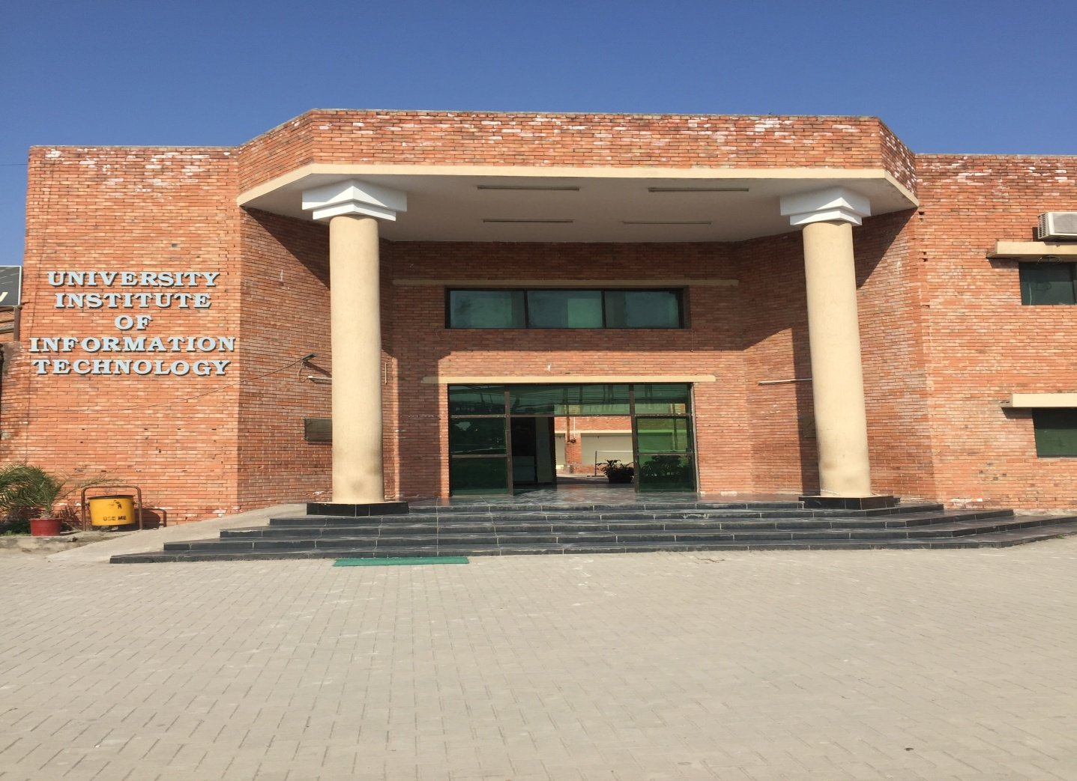

University Institute of Information Technology PMAS-Arid Agriculture University, Rawalpindi

|  |  |
| --- | --- |
| Practical - I | Creating a Virtual Machine |
| Practical - II | Installing Windows on a Virtual Machine |
| Practical - III | Installing Linux on a Virtual Machine |
| Practical - IV | Managing CPUs for a Virtual Machine |
| Practical -V | Managing Memory for a Virtual Machine |
| Practical - VI | Managing Storage for a Virtual Machine |
| Practical - VII | Managing Networking for a Virtual Machine |
| Practical - VIII | Copying a Virtual Machine |
| Practical - IX | Managing Additional Devices in Virtual Machines |
| Practical - X | Understanding Availability |
| Practical - XI | Understanding Applications in a Virtual Machine |
| Practical - XII | Dockers Orientation and setup |
| Practical - XIII | Docker Commands |
| Practical -XIV | Docker volumes Volume use cases |
| Practical -XV | Docker Swarm |
| Practical -XVI | Implement a full proof of concept application |
| Practical -XVII | [Building a Secure Docker Application](https://www.youtube.com/watch?v=tjxkxVI_PVU) |
| Practical -XVIII | Kubernetes Installation |
| Practical -XIX | Setting Up a Single Node Kubernetes Cluster Using Minikube  Accessing Minikube |
| Practical - XX | Implementation of Kubernetes Volume Management  ConfigMaps and Secrets |